LAB ASSIGNMENT 14.3

Program : B. Tech (CSE)

Specializa on : AIML

Course Title : AI Assisted coding

Semester : III

Academic Session : 2025-2026

Name of Student : Md heena

Enrollment No : 2403a54067

Batch No. : 01

Date : 28-10-2025

Task Description #1 – AI-generated HTML Page Task: Ask AI to generate a simple HTML homepage for a "Student Info Portal" with a header, naviga on menu, and footer

Expected Output: • HTML code with , , . • Clean indenta on, proper tags, and comments

Prompt: Create a basic HTML layout for a "Student Info Portal" homepage.

The structure should include a header sec on, a naviga on menu, and a footer. Ensure the code is well-forma ed with clean indenta on, appropriate HTML tags, and helpful comments for clarity.

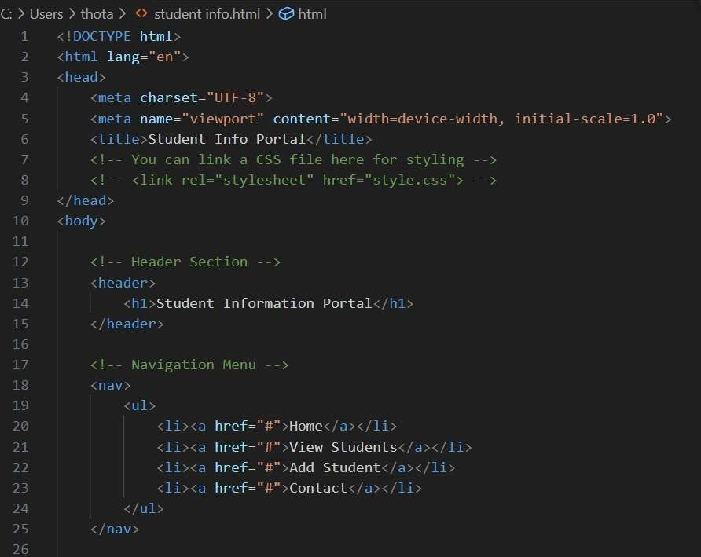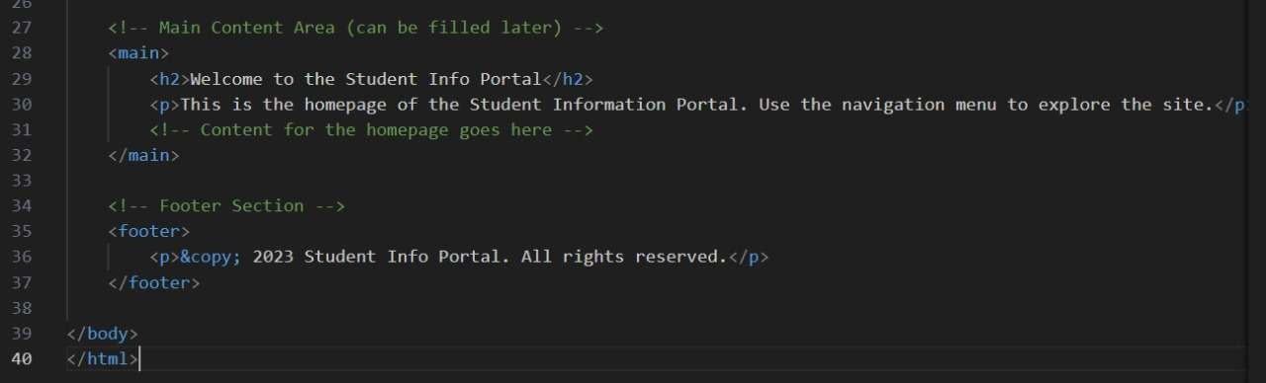

Output:

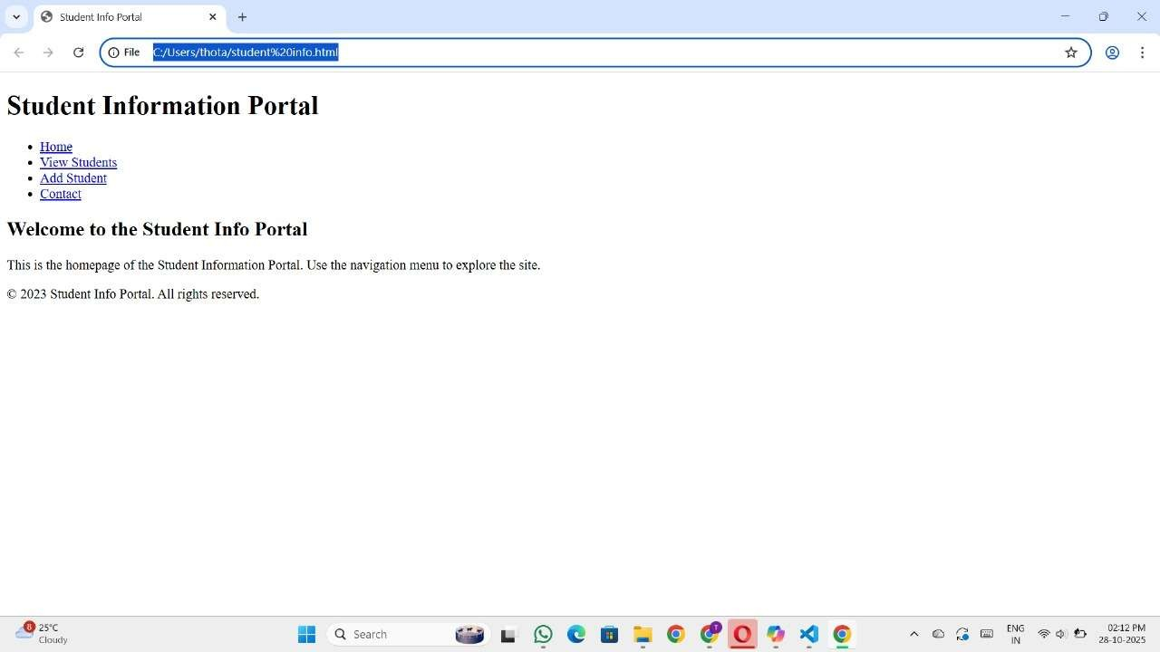

Explanation of code:

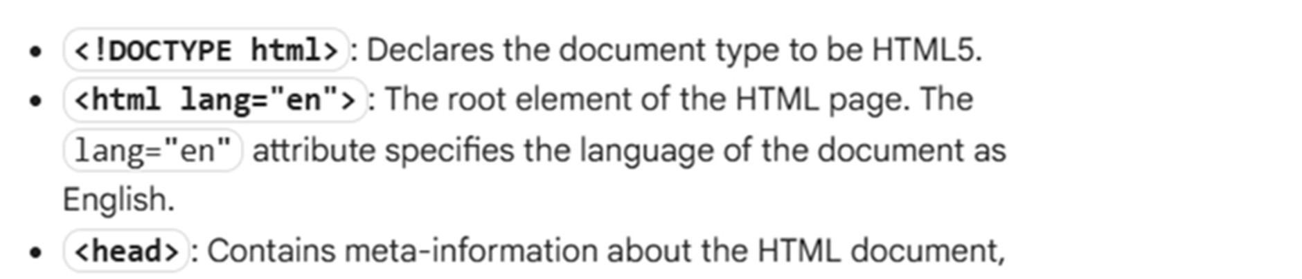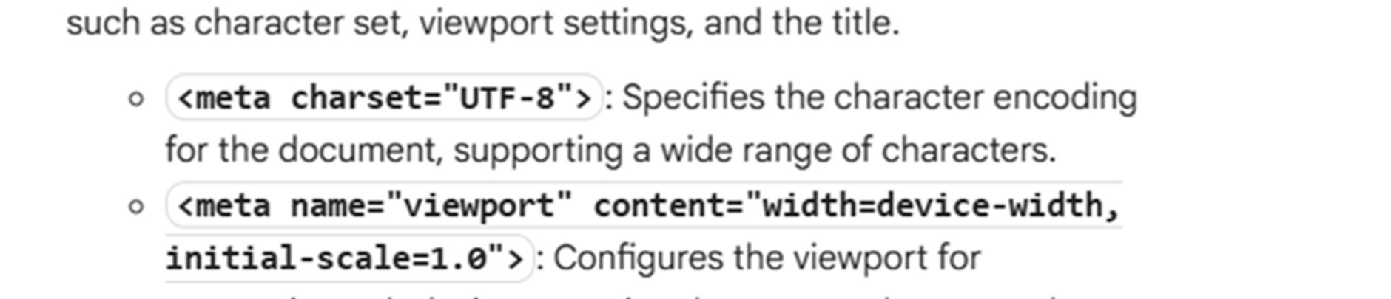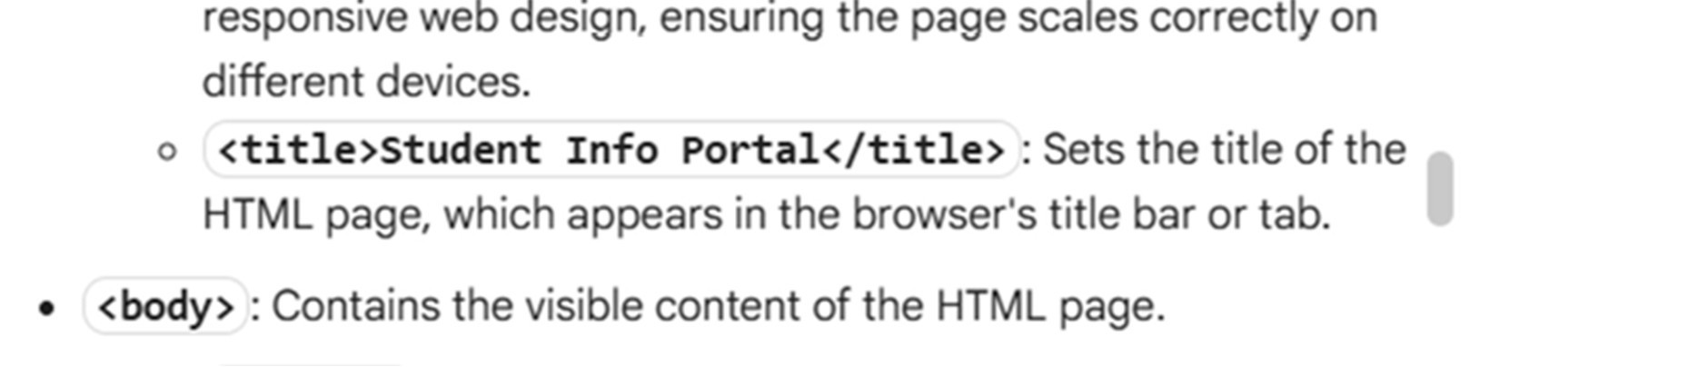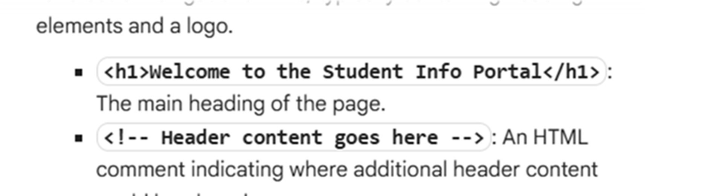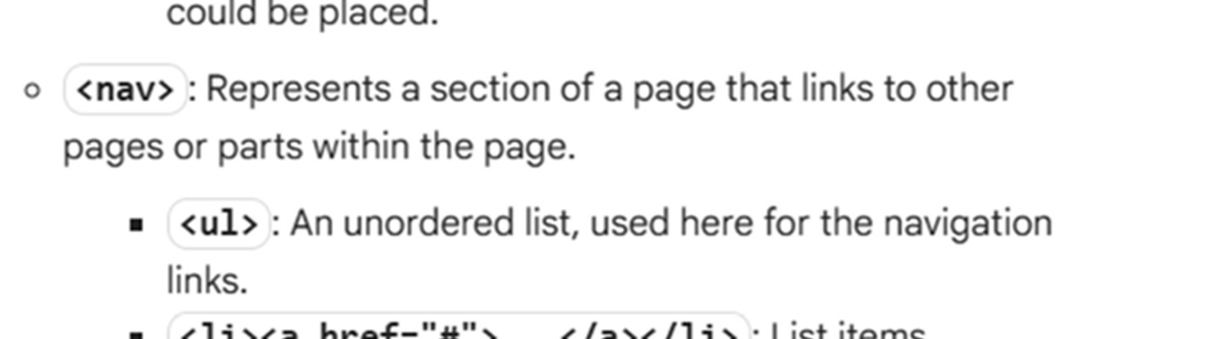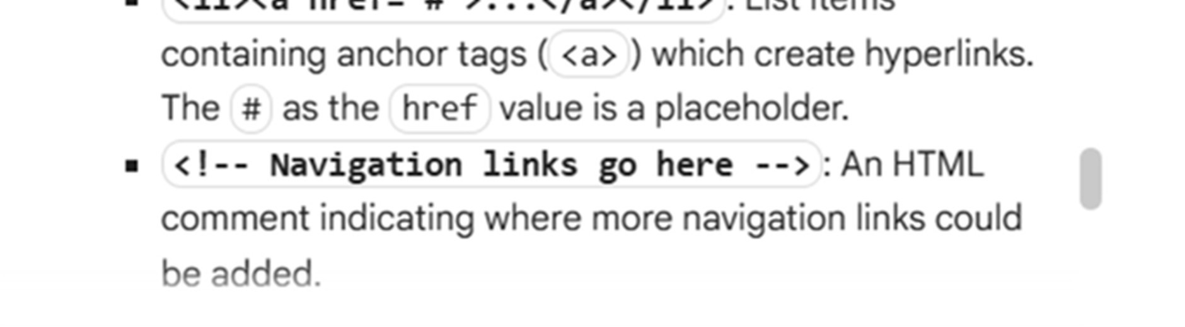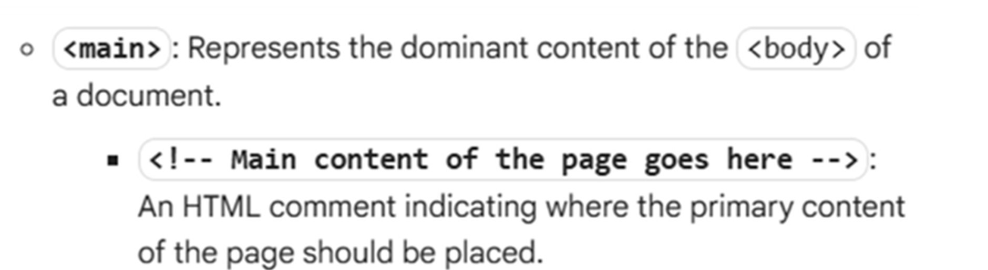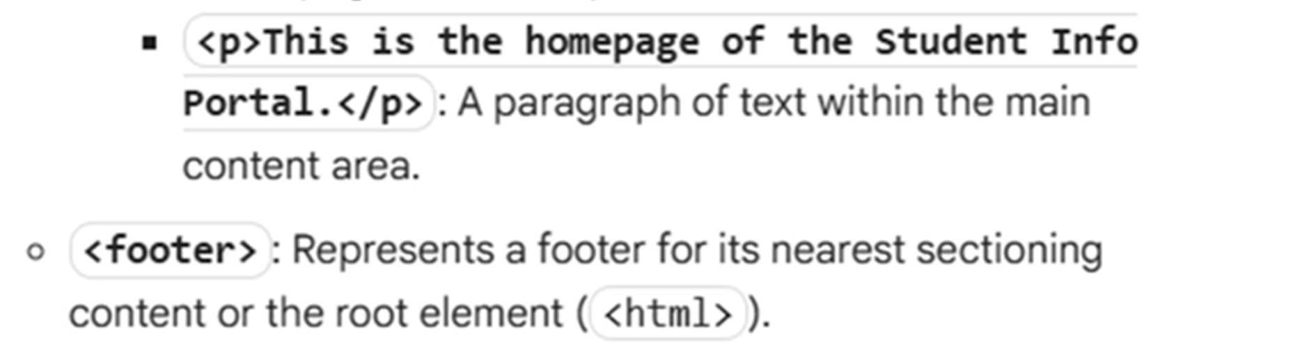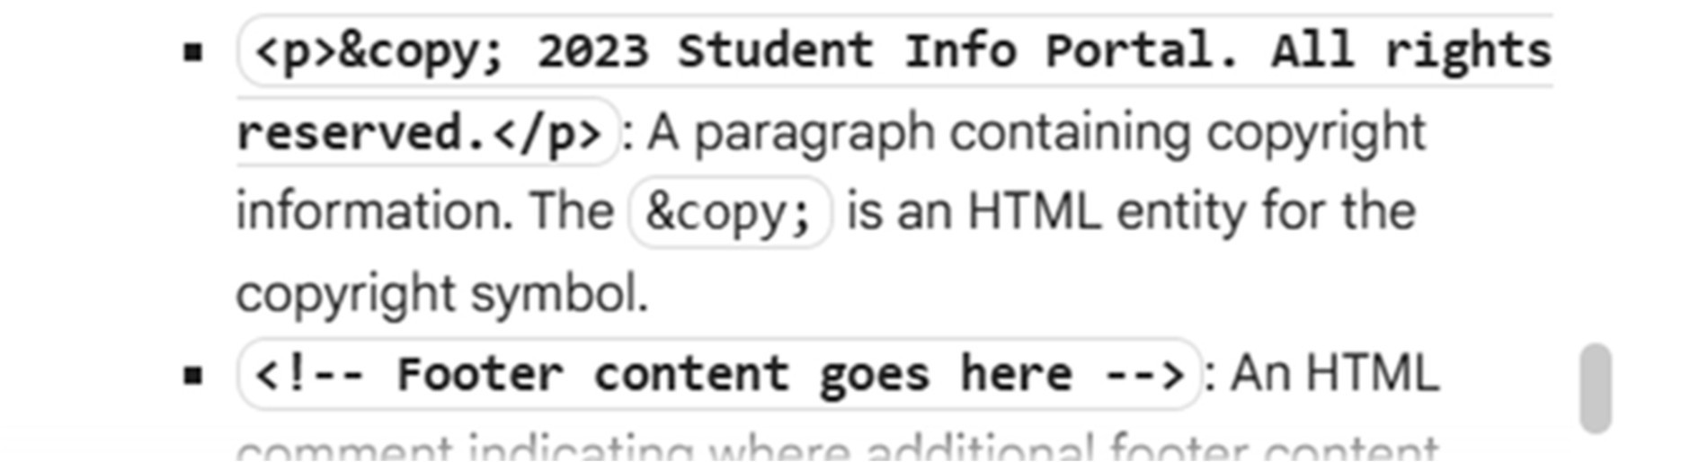

Task Description #2 – CSS Styling

Task: Use AI to add CSS styling to Task #1 homepage for: • Responsive naviga on bar. • Centered content sec on. • Footer with light gray background.

Expected Output: • HTML + CSS combined. • AI explains how CSS classes apply Expected Output: AI refactors with with open() and try-except:

Prompt:

Develop the "Student Info Portal" homepage by integra ng CSS styling directly into the HTML. The design should include:

* A responsive naviga on bar that adapts to different screen sizes
* A content sec on that is centered on the page
* A footer styled with a light gray background

Combine the HTML and CSS in a single file, and include comments or explana ons that clarify how the CSS classes are applied to structure and style the layout.

Code:

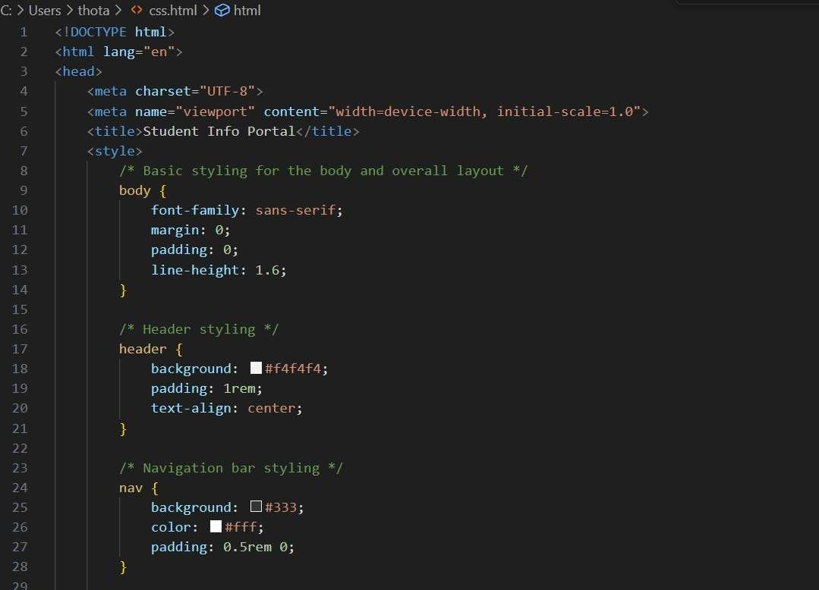

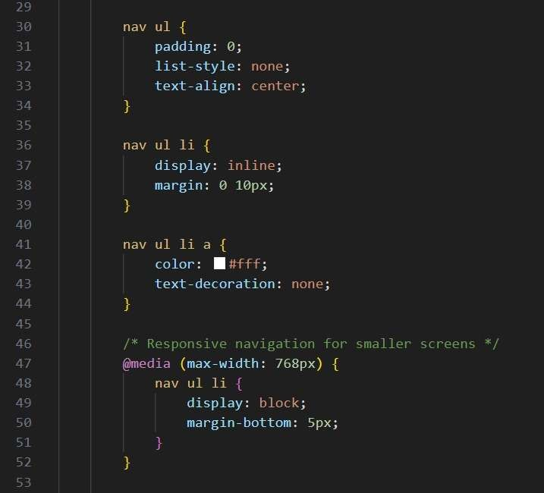

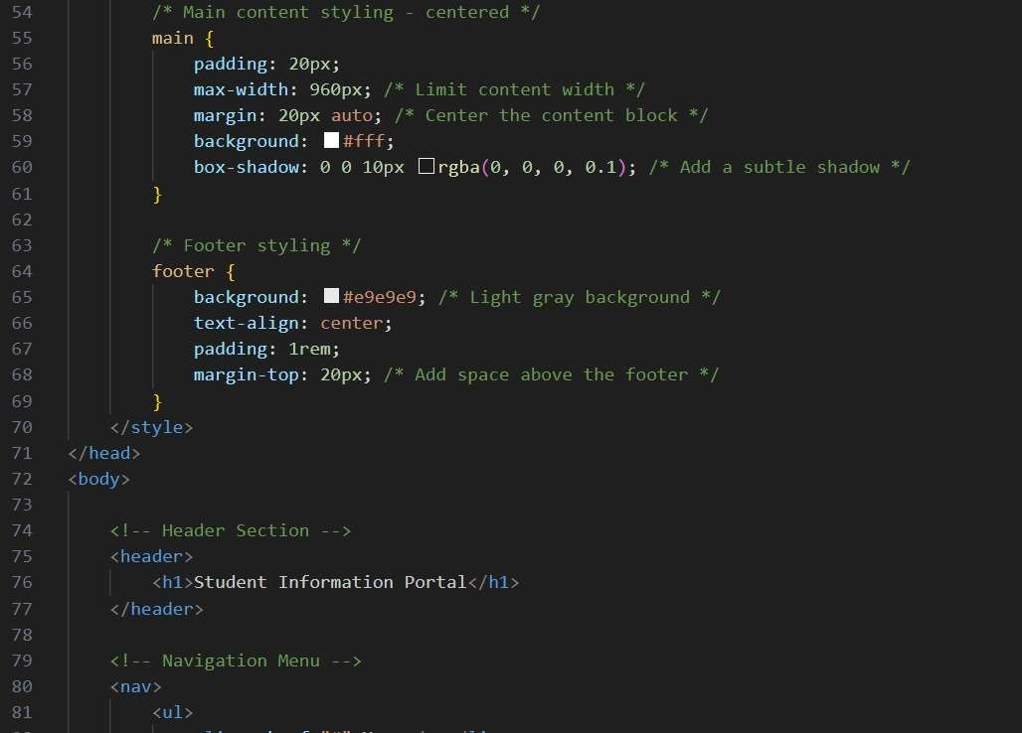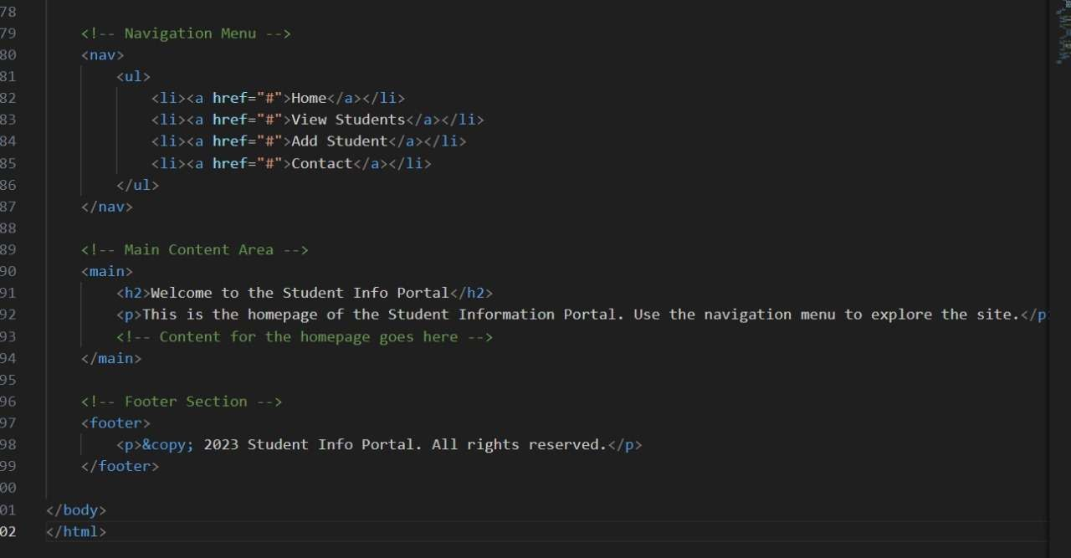

Output:

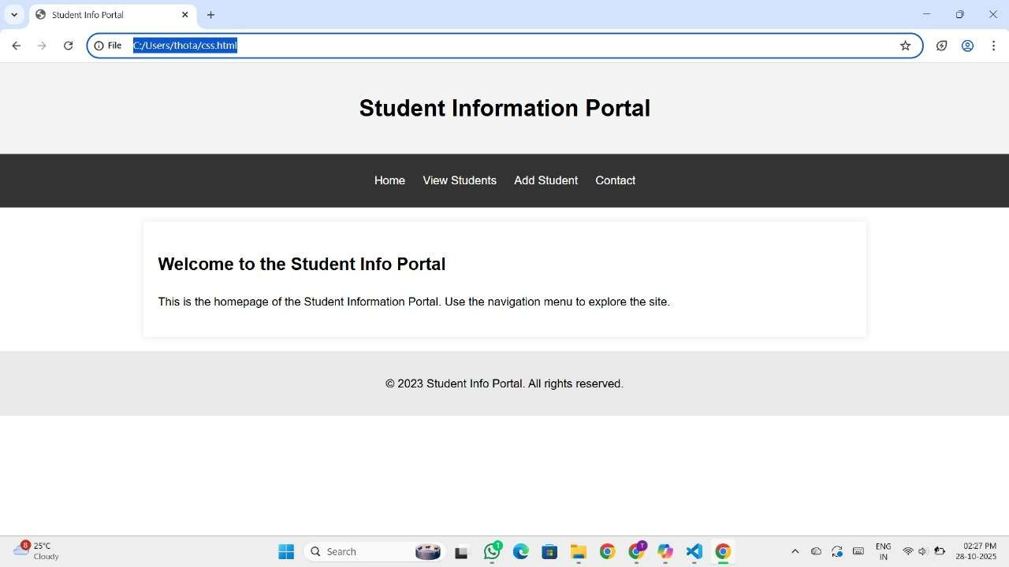

Explanation of code:

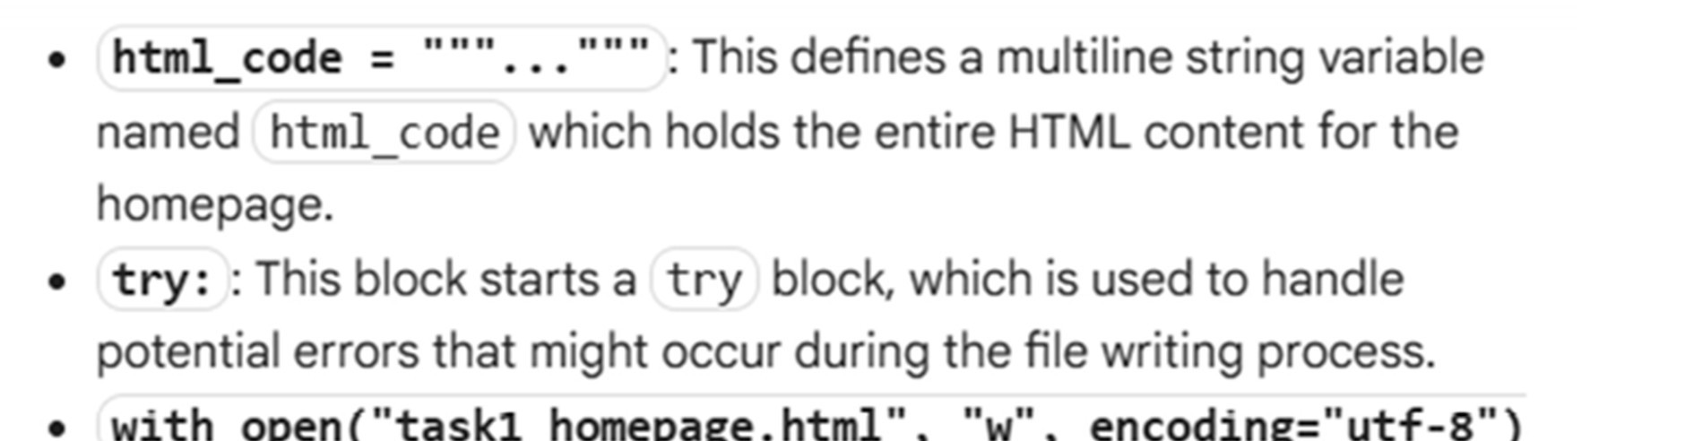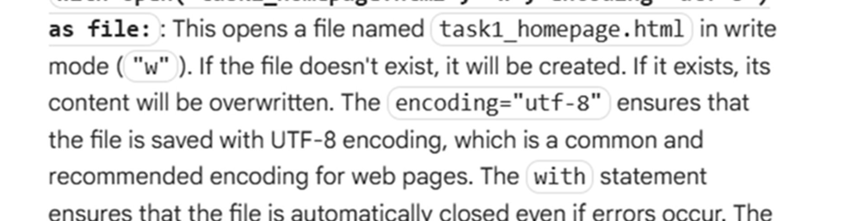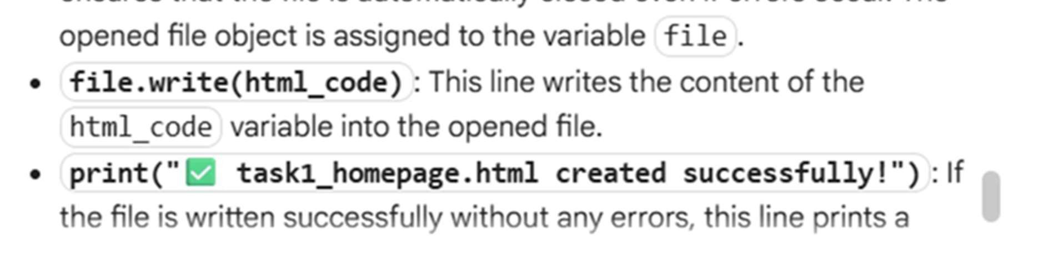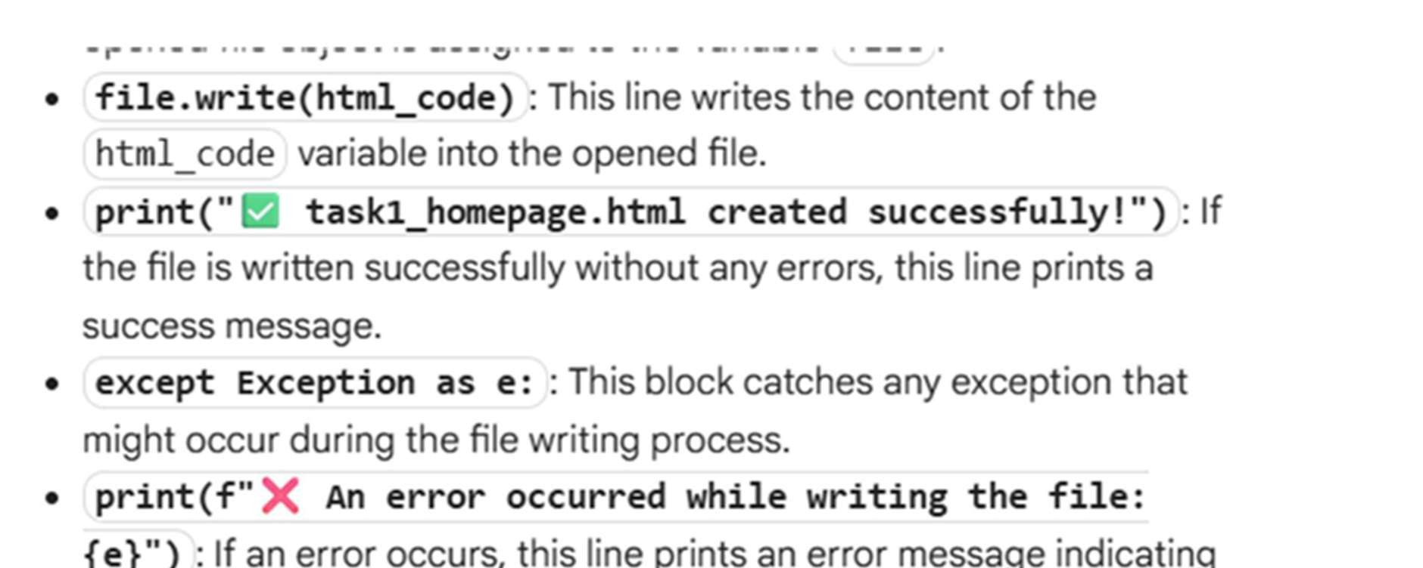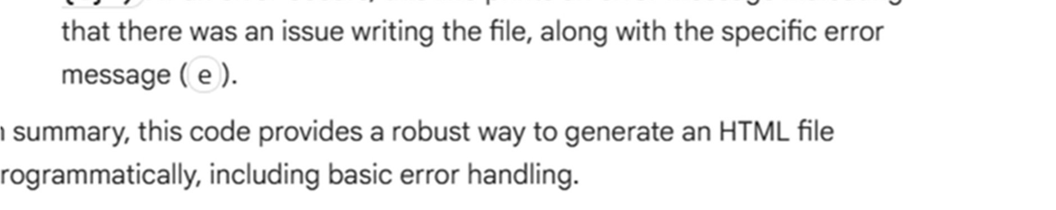

Task Description #3 – JavaScript Interactivity

Task: Prompt AI to generate a JS script that validates a simple login form (non-empty username/password)

Expected Output: Working on submit JS valida on. Clear error messages if inputs are empty.

Prompt:

Develop a code to generate Task: Prompt AI to generate a JS script that validates a simple login form (non-empty username/password). Expected Output: Working on submit JS valida on. Clear error messages if inputs are empty.

Code:

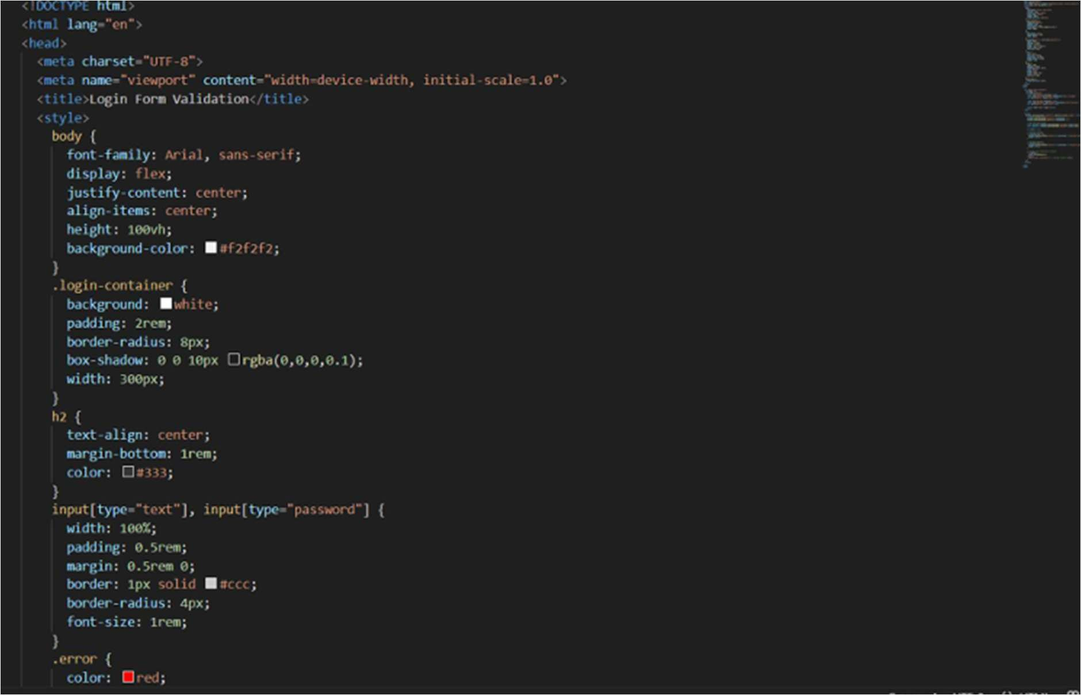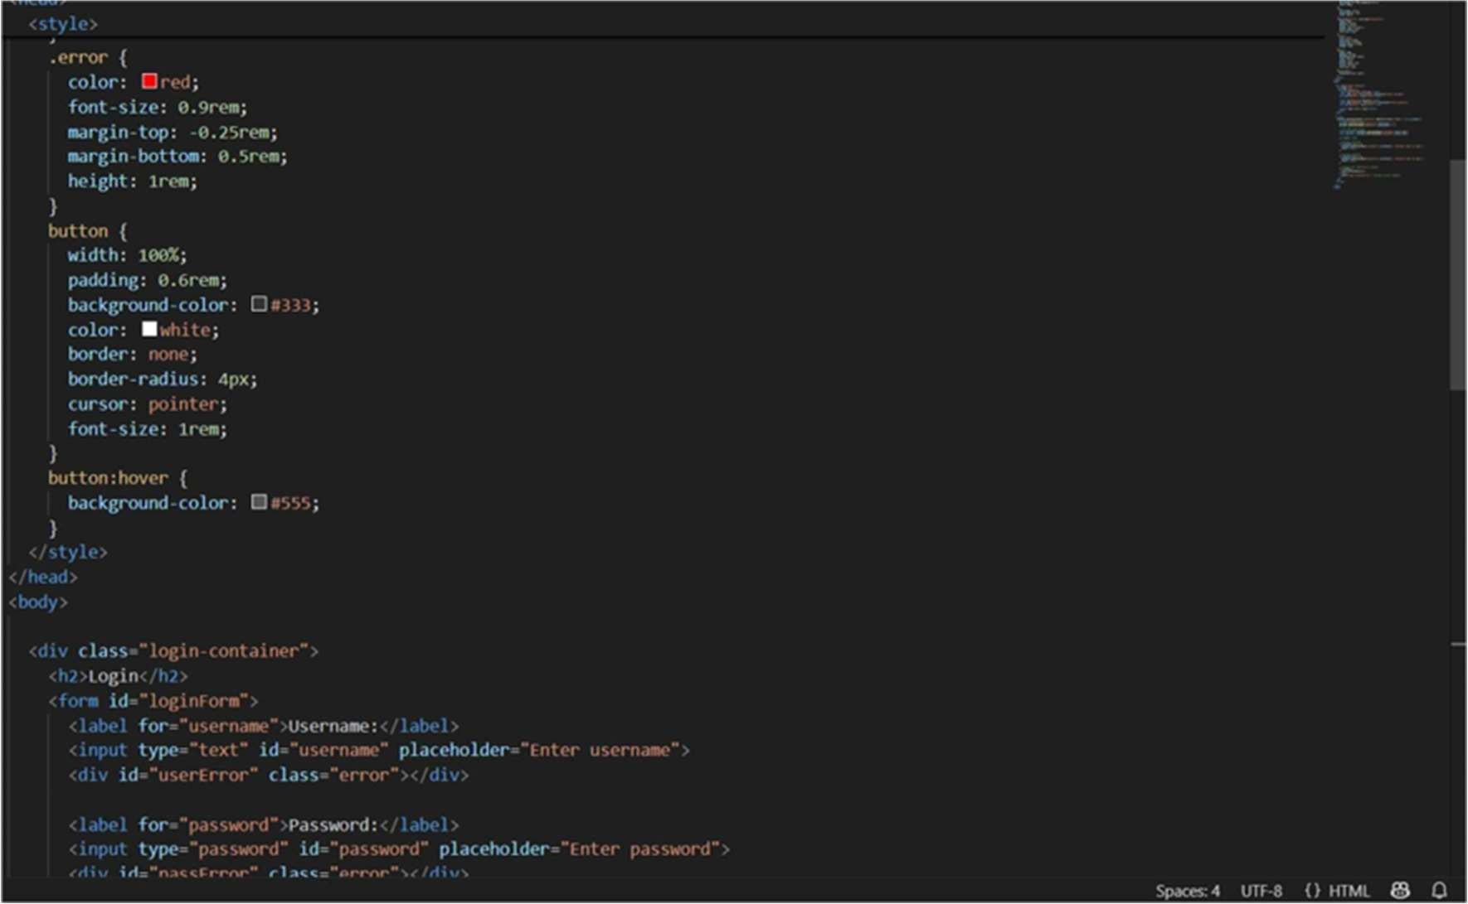

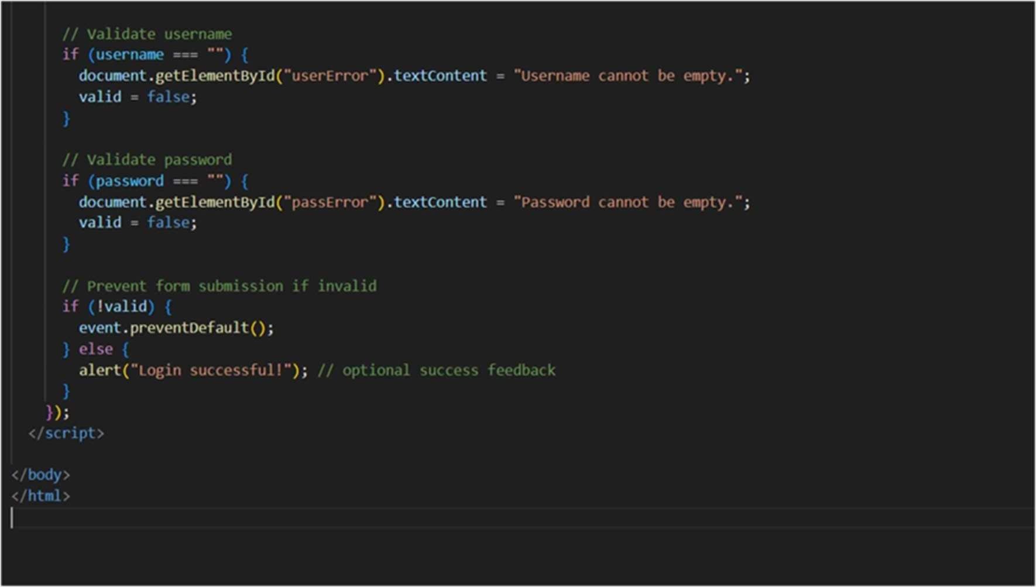

Output:

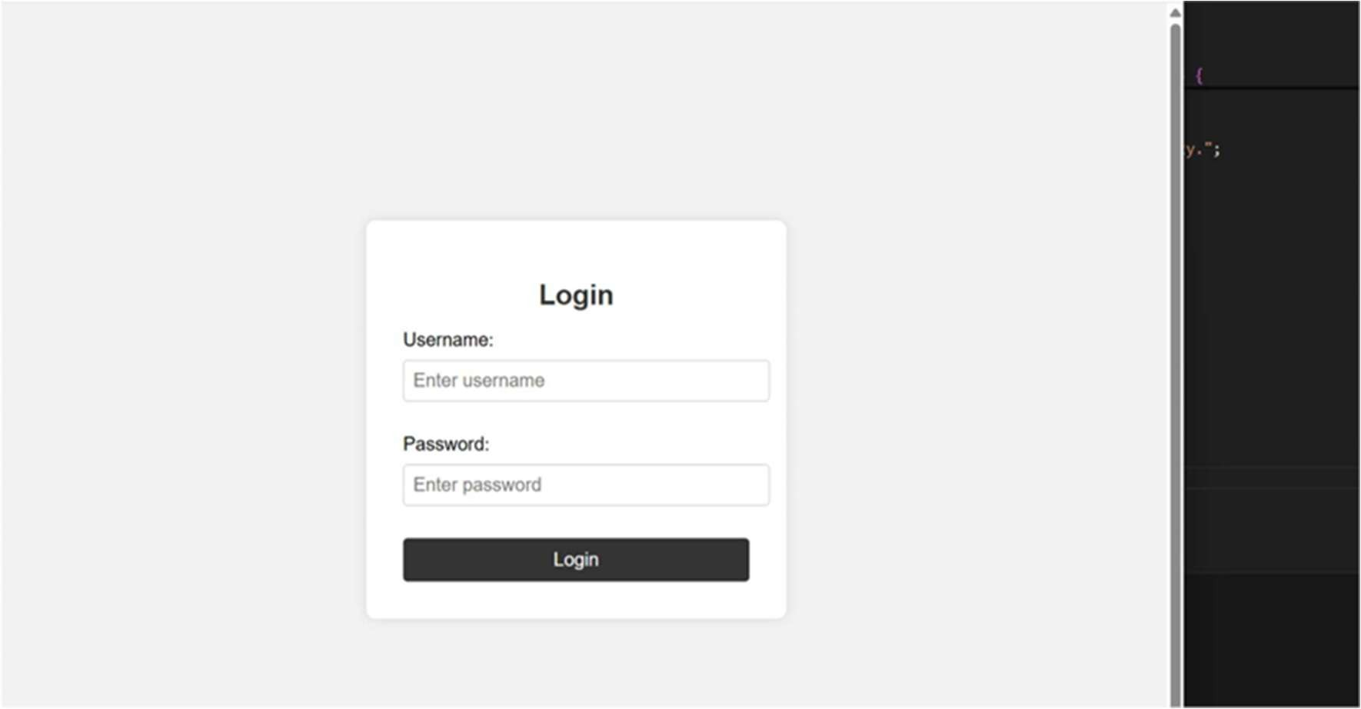

Explanation of code:

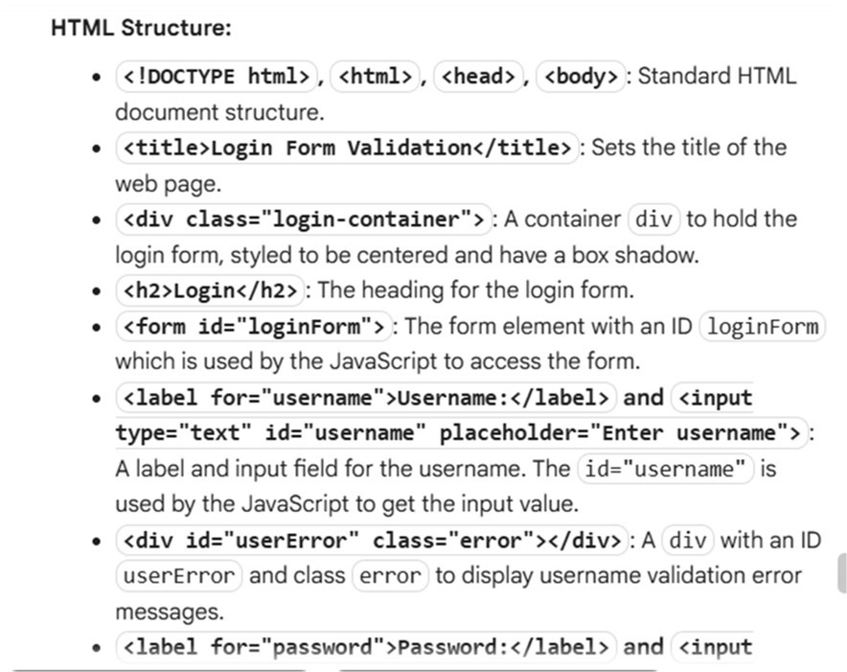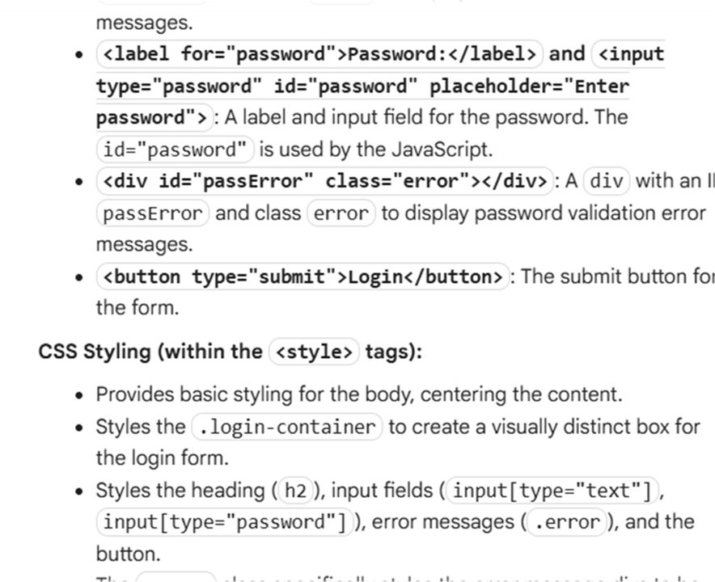

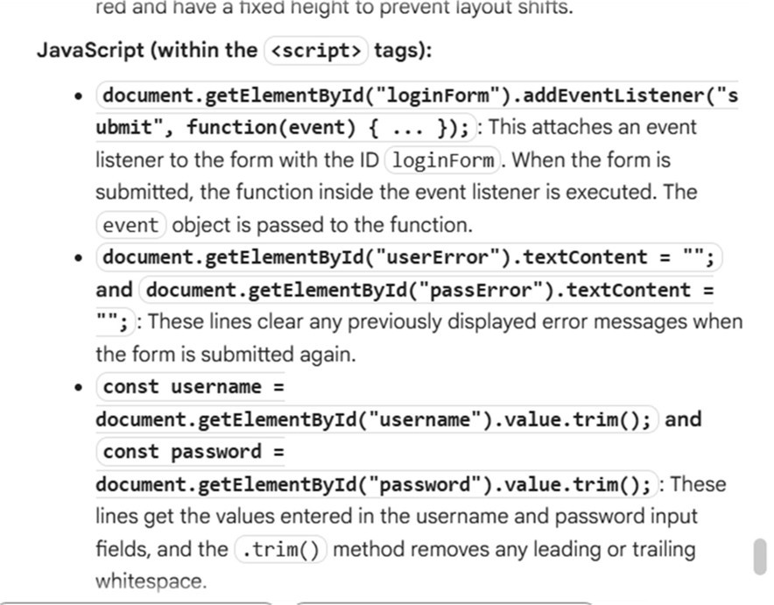

Task Description #4 – Python Backend Integration Task: Ask AI to generate a Flask app that serves the HTML form (Task #3) and prints the username on successful login.

Prompt:

Generate a code to develop Task: Ask AI to generate a Flask app that serves the HTML form (Task #3) and prints the username on successful login.

Code:

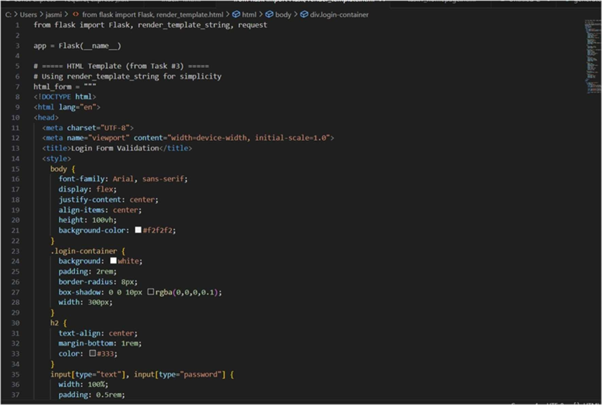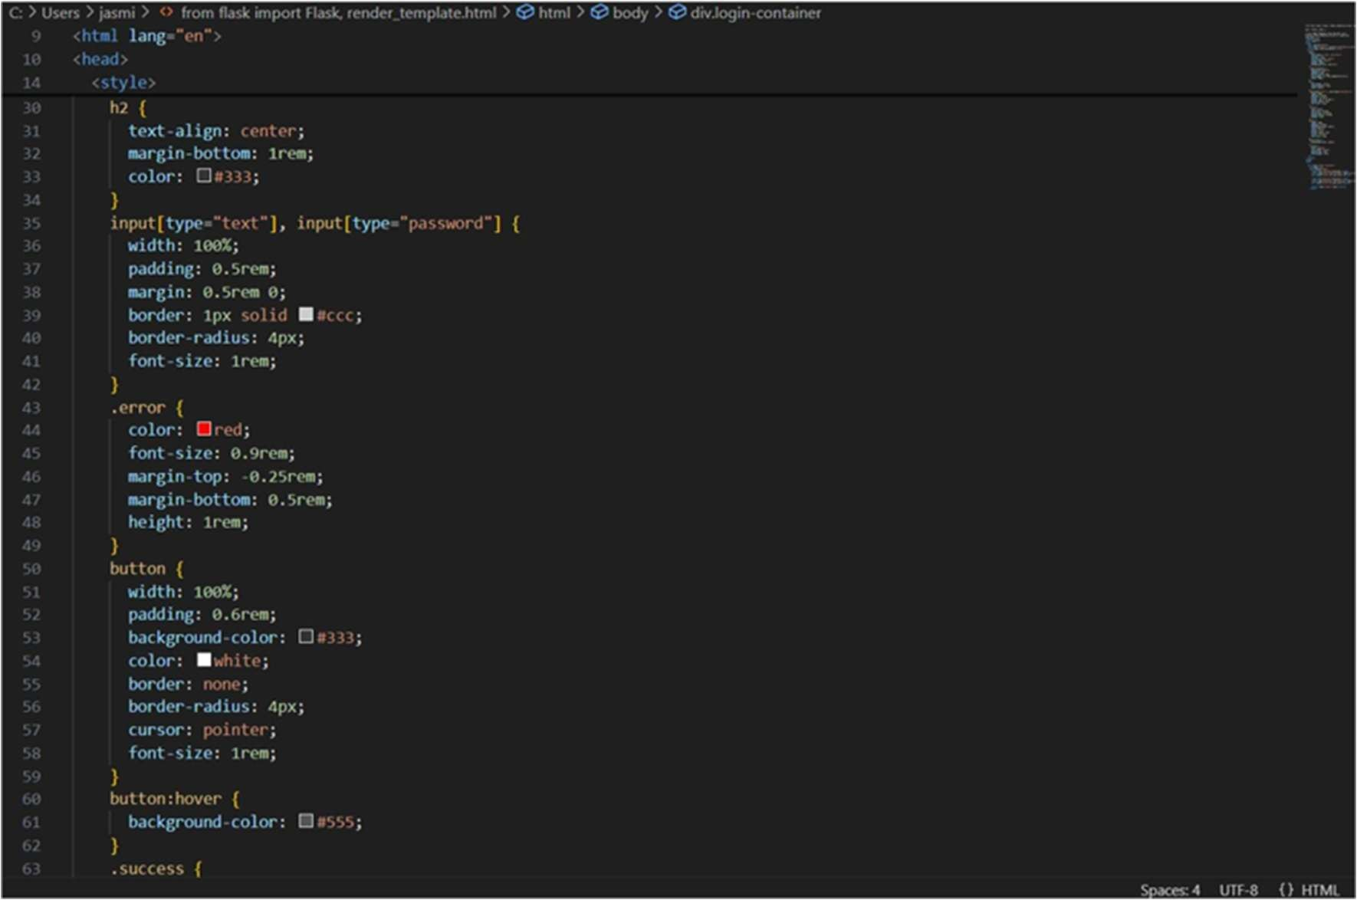

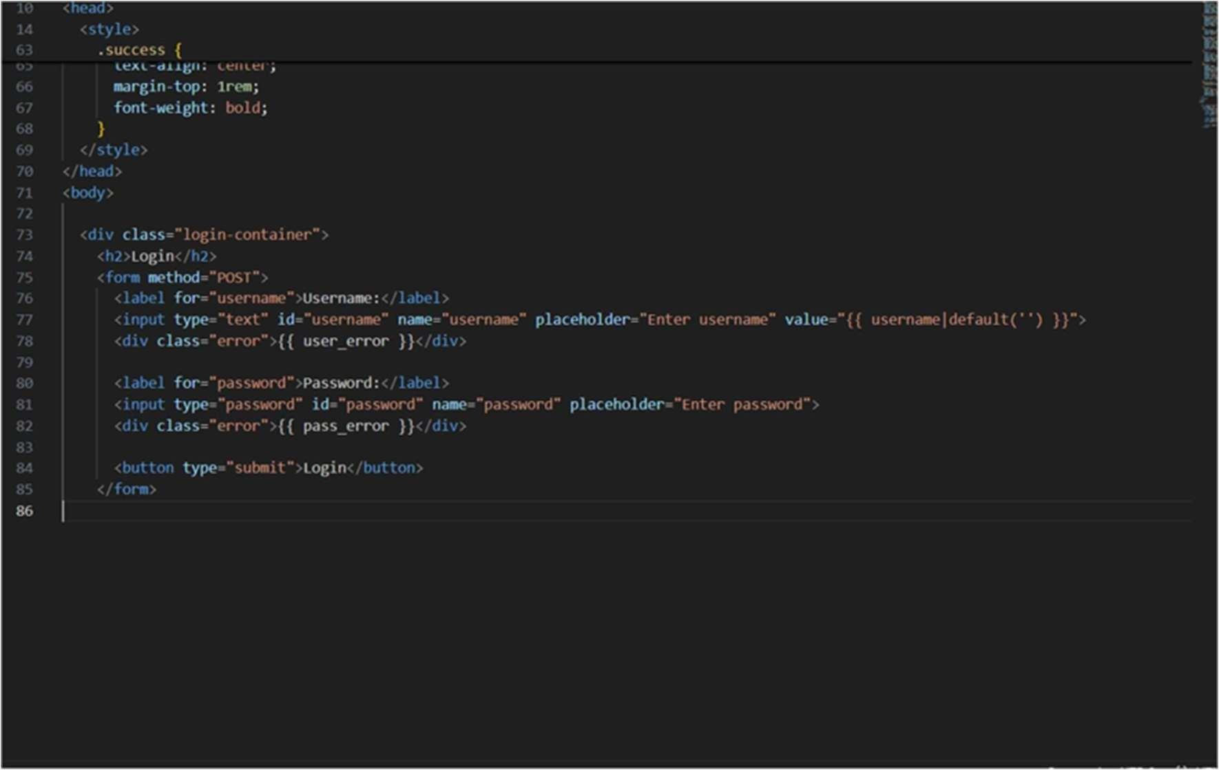

Output:

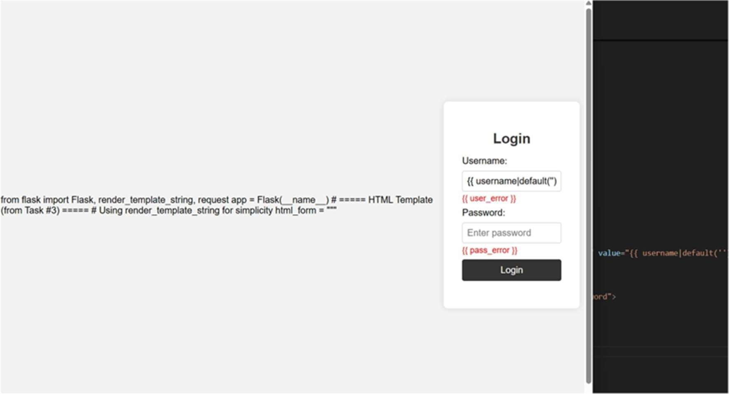

Explanation of code:

